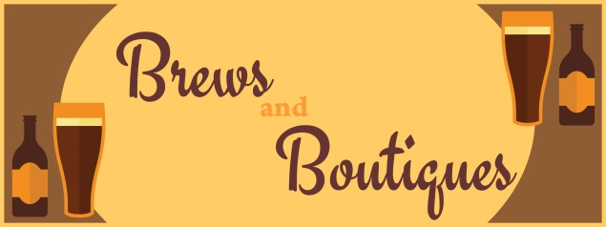
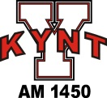

Riverfront Broadcasting, LLC of Yankton is hosting “BREWS AND BOUTIQUES” on Saturday, October 7, 2017 from 10AM until 3PM.
Thank you for your interest in being an exhibitor! Please complete the form below, review the terms and conditions and follow the instructions carefully to apply for exhibitor space. The event will be held at The Landing (104 Capitol Street – Yankton). Due to space limitations, we may not be able to accommodate all applications and/or special requests. The sooner we receive your form and fees, the better your chances are to be approved for participation and the better job we can do in organizing a great event!
Submit form to: Riverfront Broadcasting, Attn: Cynthia Miller, 202 W 2nd Street, Yankton SD 57078 or scan and email to cynthiamiller372@gmail.com
Payment: Make checks out to Riverfront Broadcasting; mail them to the address above.
Questions: Email cynthiamiller372@gmail.com or call event coordinator Cynthia Miller at 605-665-7892 during normal business hours 8AM-5PM Monday-Friday.
1) Tell us about yourself and your business (please print clearly in ink)
Booth/business name: ___ Website:
Your name: Email address:
Mailing address:
Primary phone: Secondary phone:
2) How did you hear about our event?
□ Facebook □Radio □Other:
3) What product(s) are you selling?

4) Indicate any special requests:
5) Can you donate a door prize? (If yes, please describe)
Terms and Conditions: Mail this completed application/agreement form and full payment to Riverfront Broadcasting, Attn: Cynthia Miller, 202 W 2nd Street, Yankton SD 57078. Be sure to keep a copy for your records. Or, you may scan and email your form to cynthiamiller372@gmail.com and mail your check by US mail. IMPORTANT: Your exhibitor space is not guaranteed until full payment is received. Fee will be deposited upon receipt and are not refundable. These fees will help defray the costs of advertising, venue fees and other incidental expenses of running the event. Booth space $70. Double space $130 with 1 lunch.
Confirmation/Details: Your application/agreement will be confirmed by email within 2 days of receipt of your payment. Exhibitor spaces are approximately 8’ x 8’ and will be preassigned. Tables are 6’ to allow for space in between and include a chair. Space assignments will be communicated by October 4th, along with directions for setup. Setup will begin at 8:30AM, Doors will open at 10AM. Vendors will be given until 4pm to tear down. Placement, flow and competition will be taken into consideration to provide the best experience for both exhibitors and shoppers. We will try to accommodate special requests, but cannot guarantee.
One 6’ table and a chair, 1 lunch and your business name included on marketing/radio advertising per exhibitor. You must provide any other equipment (examples: cart to load/unload, tape, display shelves, bags for your buyers’ purchases). Lunch will be prepared by The Landing.
Your exhibitor space must be fully set up and ready to sell by 10AM the day of the event. The building will be open at 8:30AM. You will need to move your vehicle/trailer away from the building after unloading to allow parking for shoppers. For everyone’s safety, tear down can start no sooner than 3PM and must be completed by 4PM. Before leaving, you must ensure your entire selling space is clean and trash-free.
Your exhibitor space must be staffed at all times. You are fully and solely responsible for any loss or damage to your property by theft, fire or casualty, without exception. You are also responsible for any damage incurred to the facility as a result of or in connection with your operations.
Release from Liability: You are responsible for carrying the appropriate insurance to protect yourself and others. In consideration of The Landing permitting you to enter upon and use its property for the purpose of participating in the “Brews and Boutiques” event, you indemnify and hold harmless The Landing, Riverfront Broadcasting and their agents from any and all bodily injury (including death), loss or property damages caused by, arising out of, related to or associated with the use of the property or the participation in the “Brews and Boutiques” event.
Sales tax: You are fully and solely responsible to remit sales and tax information to the SD Dept. of Revenue.
6) Sign below to acknowledge your application and your agreement with the terms and conditions
By signing and submitting this “Brews and Boutiques” Exhibitor Application and Agreement form, I certify that I have read and understand the Terms and Conditions and that I will adhere to the rules and policies therein.

Signature: Date:
For more information, please email cynthiamiller372@gmail.com or call Riverfront Broadcasting (KYNT/The Current 94.3/Hot Country 93.1) at 605-665-7892 and speak to Cynthia Miller. Thank you!

